GOVERNMENT COLLLEGE OF TECHNOLOGY
COIMBATORE – 641013
(An Autonomous Institution affiliated to Anna University)

7.1.4 - Water conservation facilities available in the Institution:

Sl.No | Water conservation facilities | Page
1 | Rain water harvesting | 2
2 | Borewell | 3
3 | Construction of tanks and bunds | 4-5
4 | Maintenance of water bodies and distribution system in the campus | 6

- 1. Rain water harvesting

- 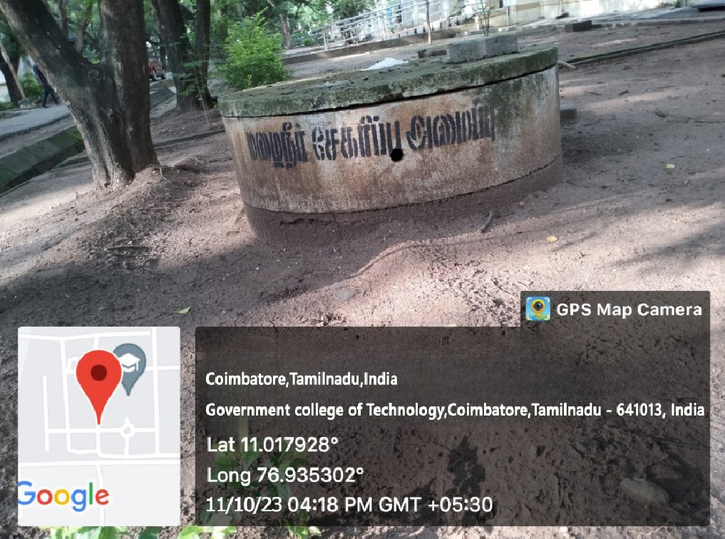
31 Rain water harvesting structure with a depth of 10ft are constructed across the campus to recharge the ground water.

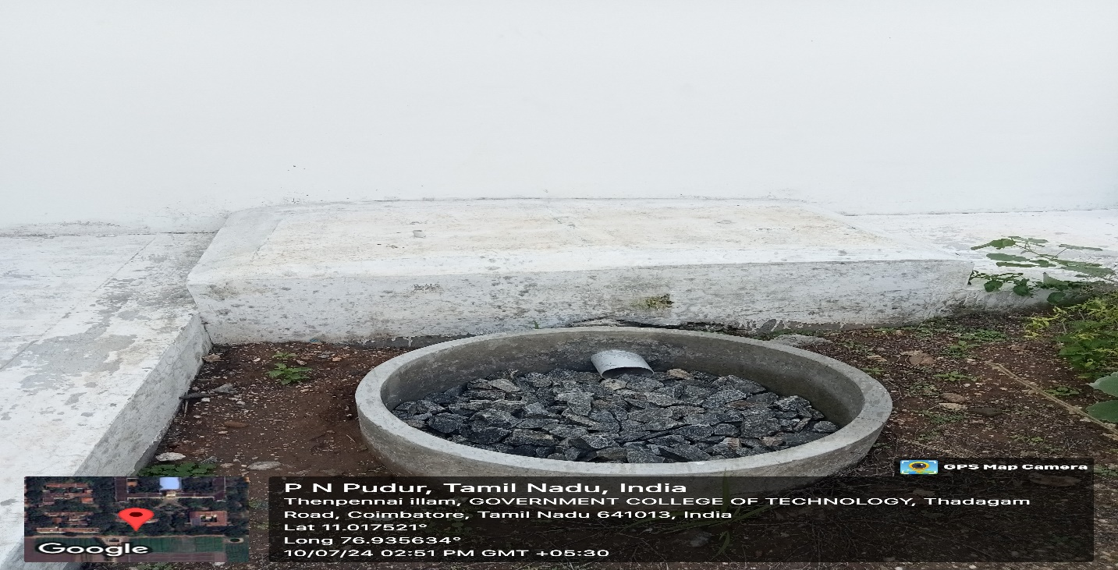
Recent installation at boys hostel

- 2. Bore well

A total of 10 borewells(7.5hp) are constructed in water abundant points inside the college for the daily needs.

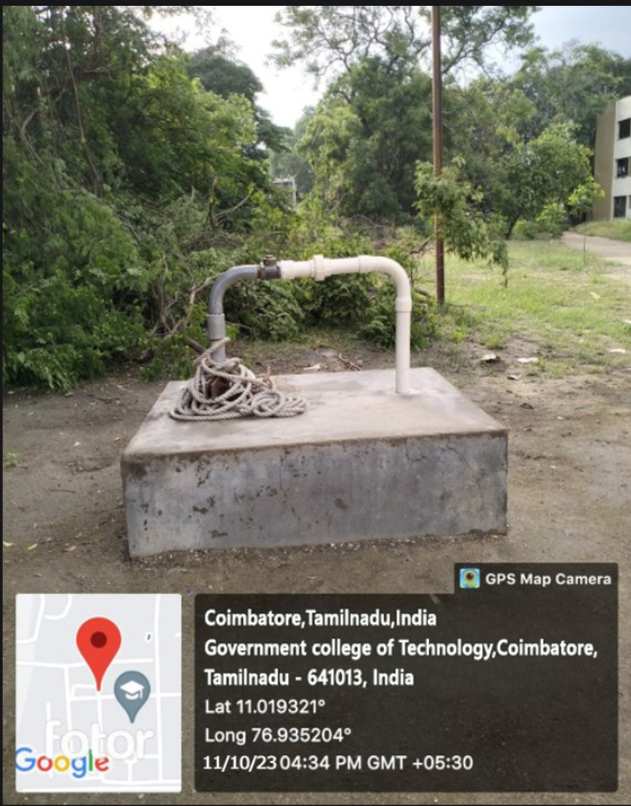

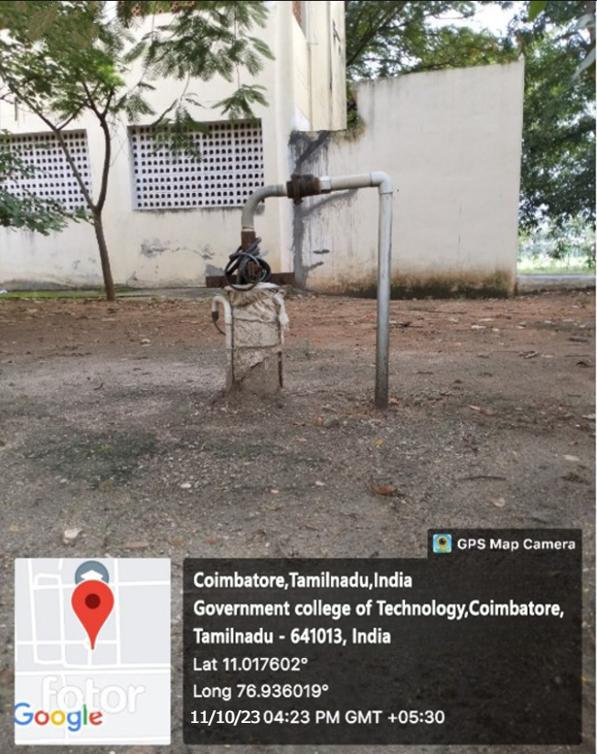

3. Construction of tanks and bunds
All the blocks are constructed with Overhead tanks
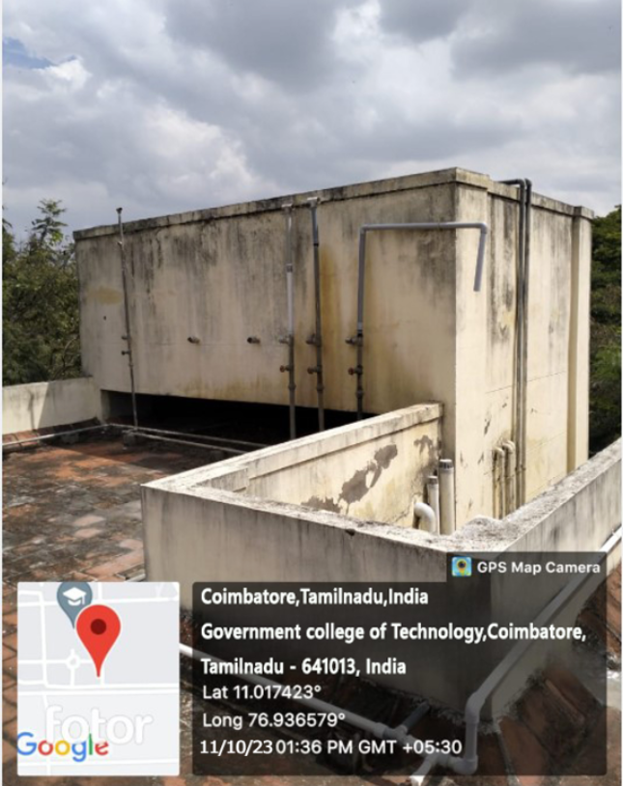

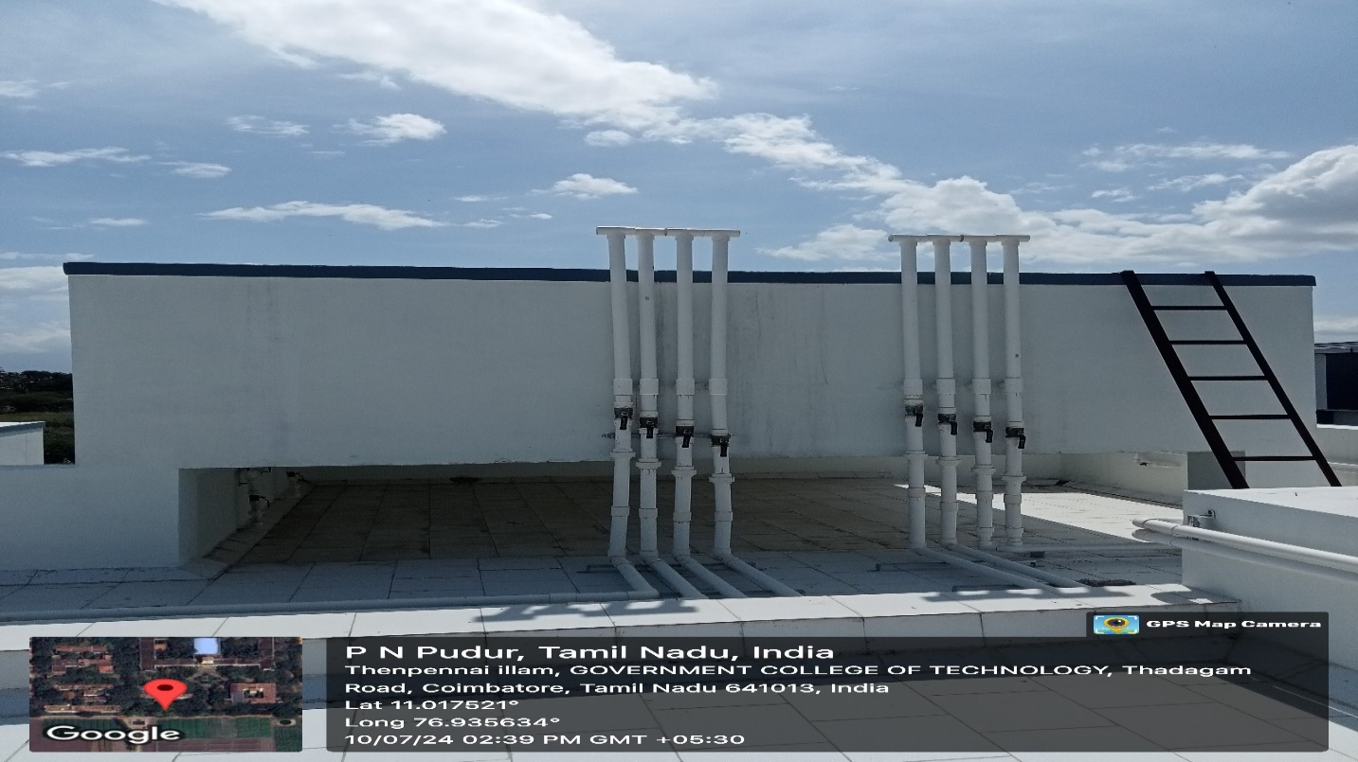
BUNDS
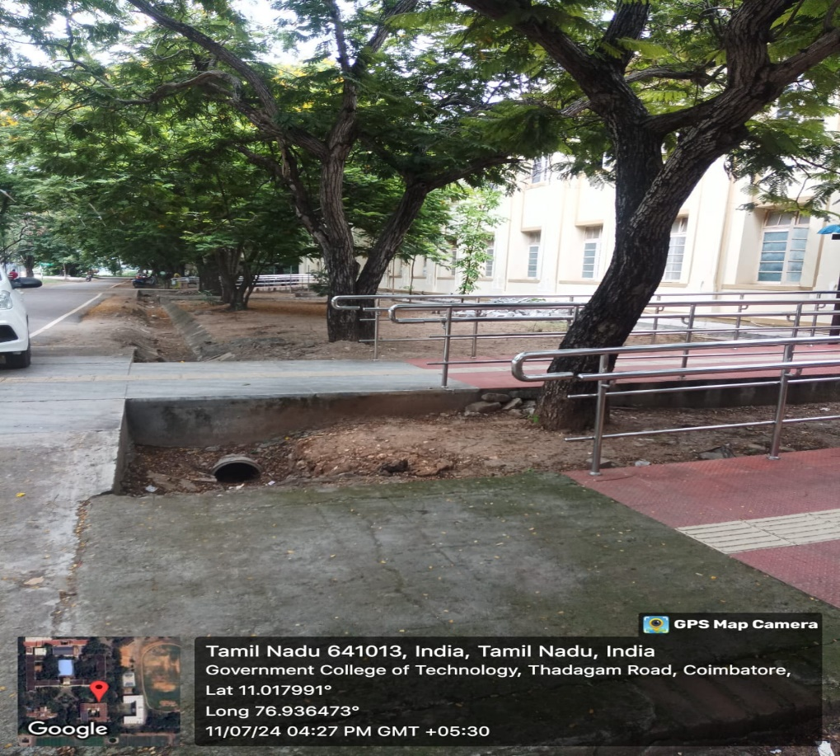
Bunds are constructed to collect the runoff water from rainfall and it is diverted to rain harvesting structure
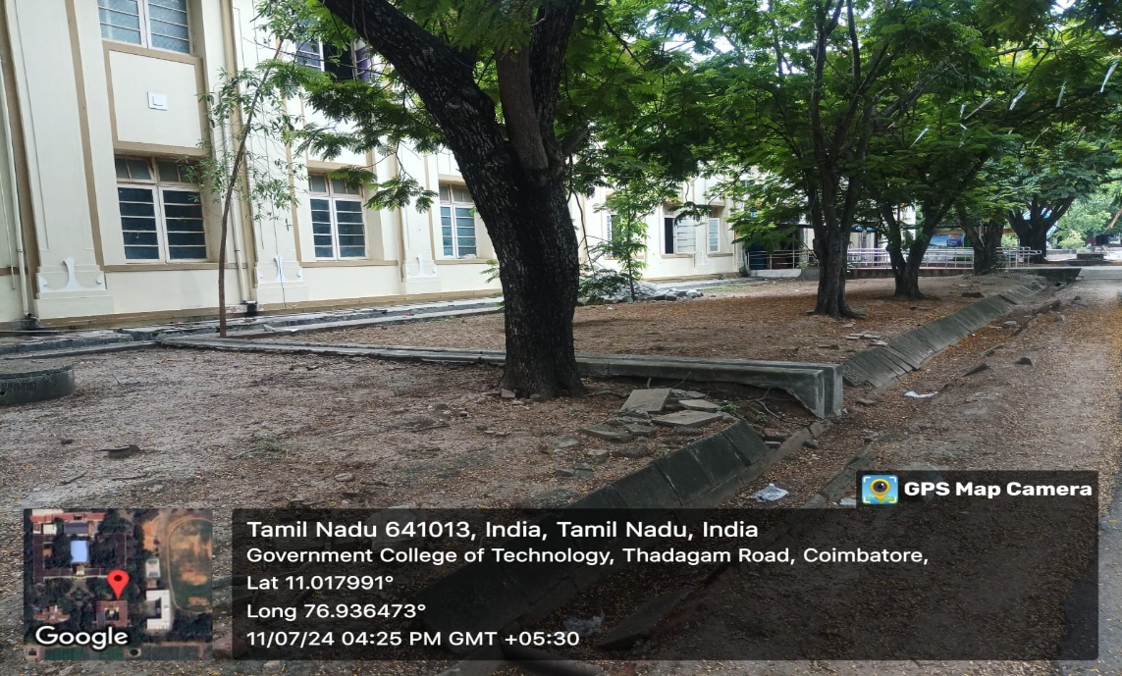

4.Maintenance of water bodies and distribution system in the campus
Krishnampathy lake is the second water body in the linkage of lakes in the northern catchment which falls under core corporation limits of Coimbatore city. The pump room located at komarapalayam was established exclusively for the Institution and the water from the lake is directly distributed through cast iron pipes to the Pump house at the campus and stored in the overhead tank . With separate distributions, water supplied to the academic and administrative buildings. A separate siruvani Drinking water supply under the Coimbatore corporation is distributed to the campus for all blocks and also treated in RO Plant for the students staying at the hostels.
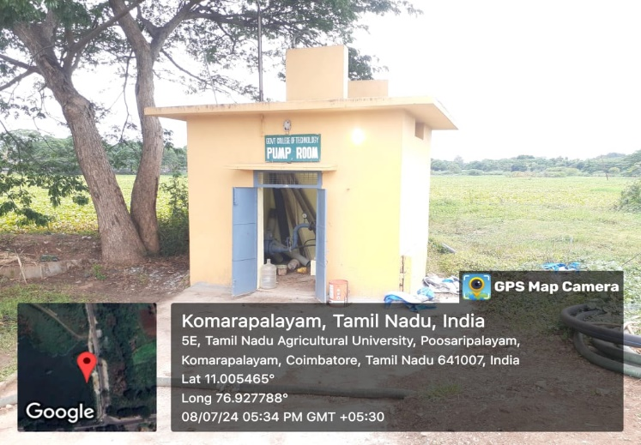 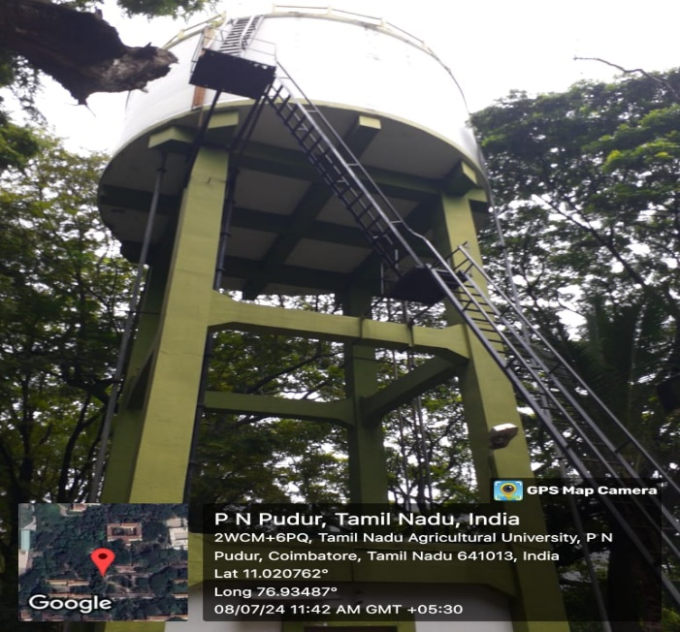 Water Pumping System Water tank
